Methodology

The data used to train and test the Machine Learning model was a combination of the data collected from the Central Pollution Control Board (CPCB - https://cpcb.nic.in/) and our IoT sensor explained in the previous section. The data collected was dated from 25th June 2018 to 1st May 2023. The Air Pollution monitoring station is situated in Jayanagar, 5th Block, Bangalore. From the open source data made available by CPCB, the following data points were collected (Note, all data points are daily averages) :- Concentrations of Particulate Matter 2.5, Particulate Matter 10, Oxides of Nitrogen, Carbon Monoxide, Ozone as we had found these to be the major contributing pollutants during the calculations of AQI. The other data points collected were Relative Humidity, Average Temperature, Wind Direction and Barometric Pressure. A separate data point called “Diwali” was added, as it was noted that the AQI was higher on the days of Diwali.

The basic Machine Learning algorithm used for training the model was AutoRegression. Variants of this algorithm such as ARMA, ARMAX, ARIMA, ARIMAX, SARIMA were explored. Breaking down the acronyms further;

AutoRegression (AR): An AutoRegressive model is a statistical model which forecasts future values based on past values. Just like how linear models make predictions based upon a combination of independent variables, AR models make predictions based on a combination of past values. This is known as autocorrelation.

Integrated Differencing (I): When the data is non-stationary, this method is performed to make the data stationary. That is, prediction is not made upon the data, rather on the differences between every 2 points of data. This may be done multiple times to remove non-stationarity. However, this is just one of the many methods of making the model deal with non-stationarity. The other methods will be discussed later.
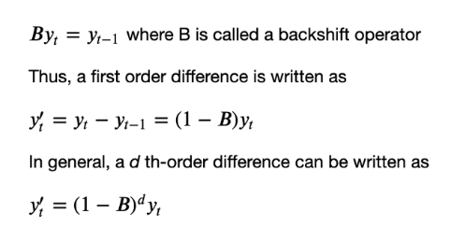
Moving Average(MA): Moving average model denotes that the forecast or result of the model depends linearly on the historical data. Additionally, it implies that predicting mistakes are linear functions of prior errors. Keep in mind that statistical moving averages are not the same as moving average models.
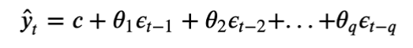

eXogenous Variables(X): These are external variables that may affect the time series forecast. For example, in the case of our modeling, Average Temperature, Diwali, etc. are eXogenous Variables. These alone are insufficient to forecast the values of AQI, however, they contribute indirectly.

Seasonality(S): This lets the model know if there is any seasonality in the data. Seasonality refers to known spikes or troughs in the time series data at a particular time every period. A period can be a day, week, month, quarter, year, etc.
In our case, we had daily data for about 5 years and a yearly seasonality where the AQI increased every winter. This made it hard for the model to catch the seasonality. Hence, in our case, instead of using a Seasonality model, it was better to model in Average Temperature and Relative Humidity as eXogenous Variables.

The parameters of the ARIMA model:

ARIMA(endog, exog=None, order=(p,d,q), seasonal_order=(P,D,Q,S), trend=None, enforce_stationarity=True, enforce_invertibility=True, concentrate_scale=False, trend_offset=1, dates=None, freq=None, missing='none', validate_specification=True)

By varying the parameters of this model, one can build AR, ARMA, ARMAX, ARMAX, ARIMAX or SARIMAX models.

For instance, if the values of P,D,Q,S are all 0s and p=1, d=0, and q=1, and exog= Null, it becomes an ARMA model. If we pass exogenous variables, it becomes an ARMAX model.

Although ARIMA models and its variants are known to be very advantageous in modeling time series, finding the right values for all parameters requires a lot of time and good modeling expertise. There is also a chance of overfitting the training data.

A quick side note on SARIMA models; while they are state of art when it comes to forecasting time series data with seasonality, they work best when the period of seasonality is low. For instance, our data consists of daily AQI values and a yearly trend or in other words, daily data and a seasonality period of 365 days. This becomes very cumbersome for the model and hence, we opted to model the seasonality by using Average Temperature as an exogenous variable.

MODEL (Parameters) | MSE
Predicting based on previous day | 577.05
AutoReg(lags=17, trend=’t’) | 917.961
ARMA:  ARIMA(p=4, d=0, q=1, trend=’t’, exog=Null) | 449.86
ARIMA(p=3, d=1, q=1, trend=’t’, exog=Null) | 450.586
ARMAX(p=4,d=0,q=1, trend=’t’, exog=[‘Average Temperature’]) | 421.21
ARMAX(p=4,d=0,q=1, trend=’t’, exog=[‘Average Temperature’,’Diwali’]) | 320.125
ARMAX(p=4,d=0,q=1, trend=’t’, exog=[‘Relative Humidity’,’Wind Direction’]) | 376.463
ARMAX(p=4,d=0,q=1, trend=’t’, exog=[‘Average Temperature’,’Diwali’,‘Relative Humidity’,’Wind Direction’,’Barometric Pressure’]) | 295.075
ARMAX(p=4,d=0,q=1, trend=’t’, exog=[‘Average Temperature’,’Diwali’,‘Relative Humidity’]) | 279.228

